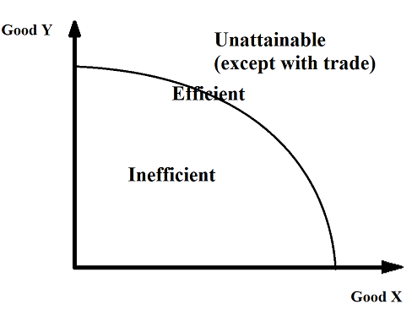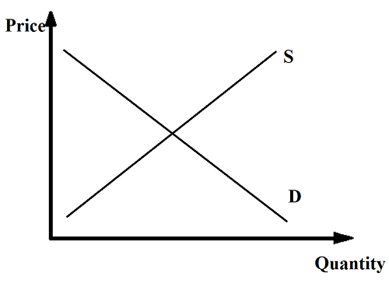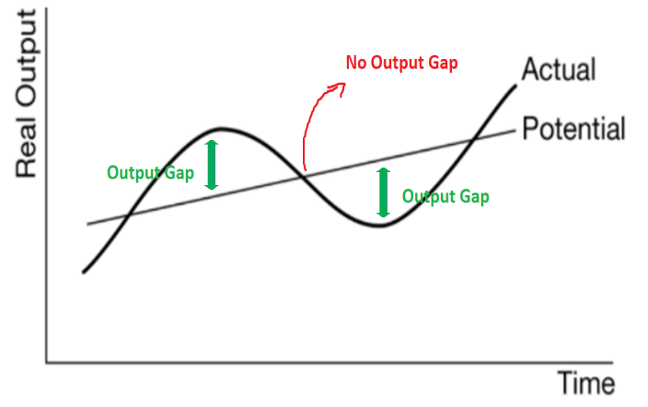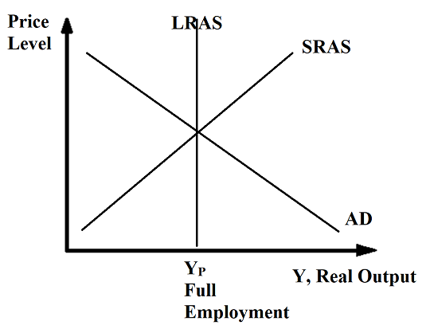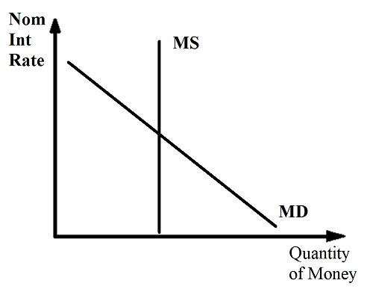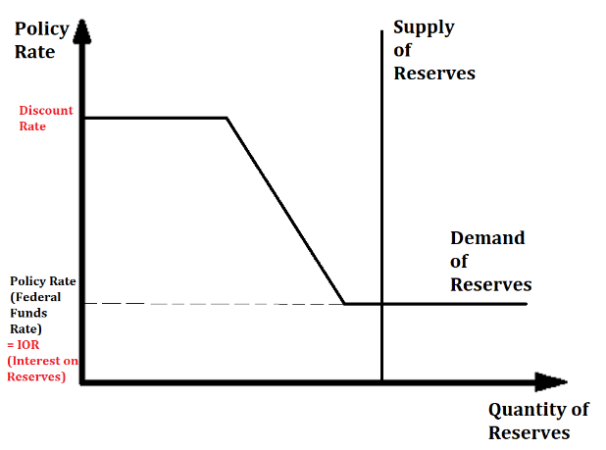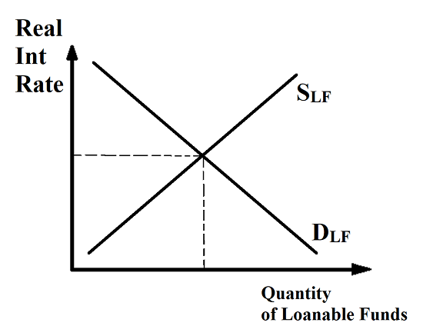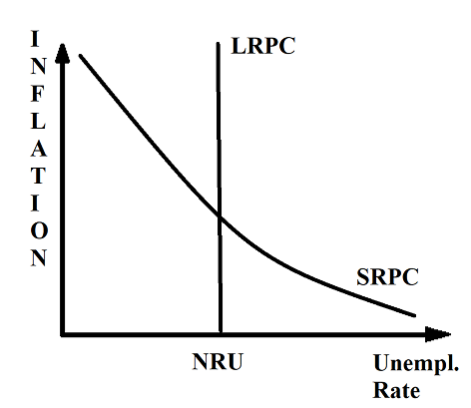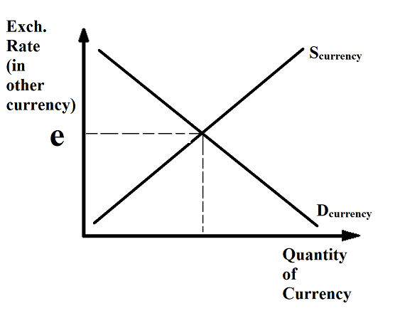
Foreign Currency Market
Loanable Funds Market
Reserves Market
Demand and Supply
Phillips Curve
Money Market
AD/AS
Business Cycle
PPC

Main Graphs

Unit 1
Opportunity Cost
Next best opportunity foregone when a decision is made.

Economic Systems:
Market, Planned, Mixed

Gains from Trade
Countries can only produce on their PPC, but through trade can consume beyond their PPC.

PPC Shape
Straight = constant opportunity cost, resources are the same
Curved = increasing OC, resources are not the same.

Output Question: | Input Question:
Absolute advantage = larger number  Opportunity Cost = Given up units / gained units  Comparative Advantage = lower opportunity cost  Terms of trade = between lower OC and higher OC | Absolute advantage = smaller number  Opportunity Cost = Inputs to produce / inputs to produce other good (opposite of output question)  Comparative Advantage = lower opportunity cost  Terms of trade = between lower OC and higher OC
Terms of Trade
Range of prices that benefit both countries.
In between the two OCs for one of the goods.

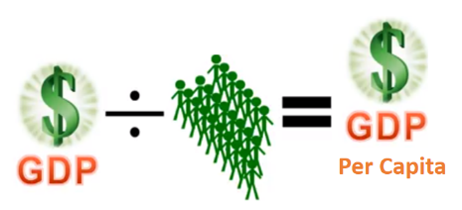
Unit 2
- Non-market activities (ppt section)
  - Shadow economy
    - Eg. A plumber fixes a friend’s sink
    - A farmer sells fruit at the side of a road
    - Illegal activities
- Environmental Things
  - polar bears are born
  - a rainforest is cut down (arguably this should decrease GDP but is not counted)
- Wealth Inequality
  - A country could have a high GDP and even high GDP per capita but that could be due to many very rich, even if there are many poor in society. Wealth inequality is considered a negative thing.

GDP
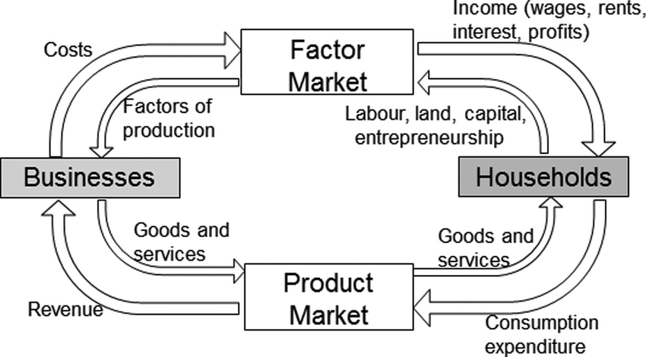
Factor Incomes Method
Wages + Interest + Land + Profit
Value Added Method
Value of output – inputs
- Total Expenditure Method
- GDP = C+I+G+(X-M)
3 Ways of Calculating GDP (Gross Domestic Product)
- Non-market activities (ppt section)
  - Shadow economy
    - Eg. A plumber fixes a friend’s sink
    - A farmer sells fruit at the side of a road
    - Illegal activities
- Environmental Things
  - polar bears are born
  - a rainforest is cut down (arguably this should decrease GDP but is not counted)
- Wealth Inequality
  - A country could have a high GDP and even high GDP per capita but that could be due to many very rich, even if there are many poor in society. Wealth inequality is considered a negative thing.

Unemployment
Labor Force Participation Rate (LFPR) = labor force / working age population
= (employed + unemployed) / Working age population
Labor Force = employed + unemployed
Unemployment Rate with more discouraged workers
= (Unemployed – X) / (Labor force – X)

Natural Rate of Unemployment:
NRU = Frictional + Structural
= (Frictionally unemployed + structurally unemployed) / labor force
Actual Rate of Unempl = NRU + cyclical
When there is the NRU, cyclical unemployment = 0
- Unemployment Rate = unemployed / labor force
- = unemployed / (employed + unemployed)

Inflation
CPI = Market Basket / Market Basket_{base year} x 100
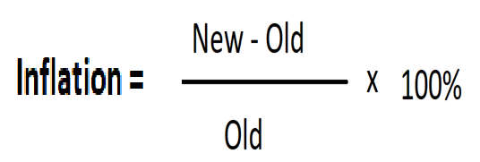
GDP Deflator = NGDP/RGDP x 100
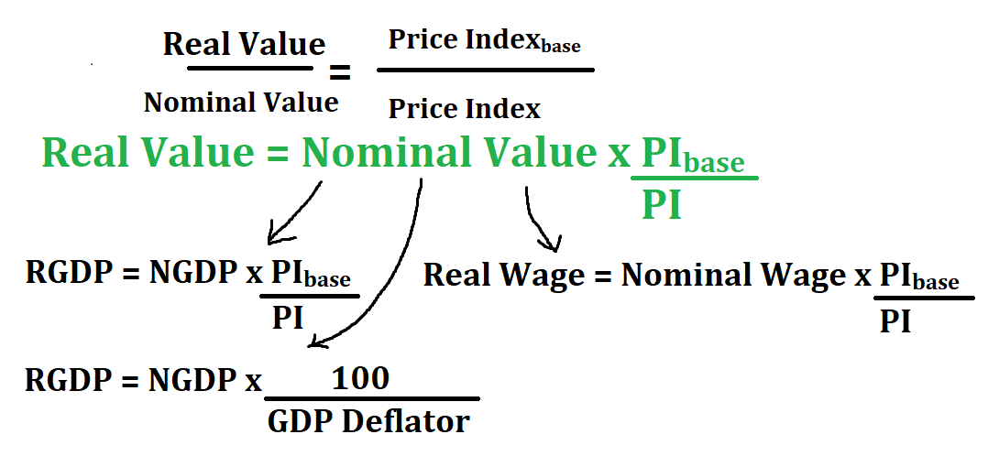
Approximate: %△ Real Value = %△ Nominal Value – Inflation, but this is only an approximation
Eg. Your boss gives you a raise of 5% from last year and inflation is 3%. Your real wages have increased by 5-3=2% approximately.
Actual Inflation = Expected Inflation + Unexpected Inflation
(Unexpected Inflation – benefits borrowers, Unexpected deflation – benefits lenders)
Real Interest Rate = Nominal Interest Rate – Inflation
Ie. RIR = NIR - Infl

Unit 3
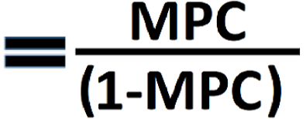
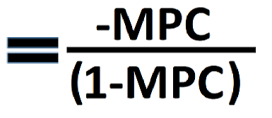
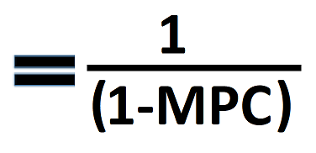
Government spending and tax at the same time.
∆GDP = ∆Income = ∆G x Multiplier + ∆Tax x Tax Multiplier
- If the ∆Tax = ∆G, then AD will increase because spending multiplier is larger than tax multiplier.
- Effect on Economy:
- ∆AD = ∆GDP = ∆Income = ∆Initial Spending x Multiplier
- ∆AD = ∆GDP = ∆Income = ∆Tax x Tax Multiplier
- ∆AD = ∆GDP = ∆Income = ∆Transfer Payment x Transfer Payment Multiplier
Or MPC/MPS
Government Transfer Multiplier
Spending Multiplier
Government Tax Multiplier
Or -MPC/MPS
Or 1/MPS
Or 1/MPS
Disposable Income (Y_{D}) = Income - Taxes
MPC = Marginal Propensity to Consume = ∆Consumption / ∆Disposable Income
MPS = Marginal Propensity to Save = ∆Saving / ∆Disposable Income
MPC + MPS = 1
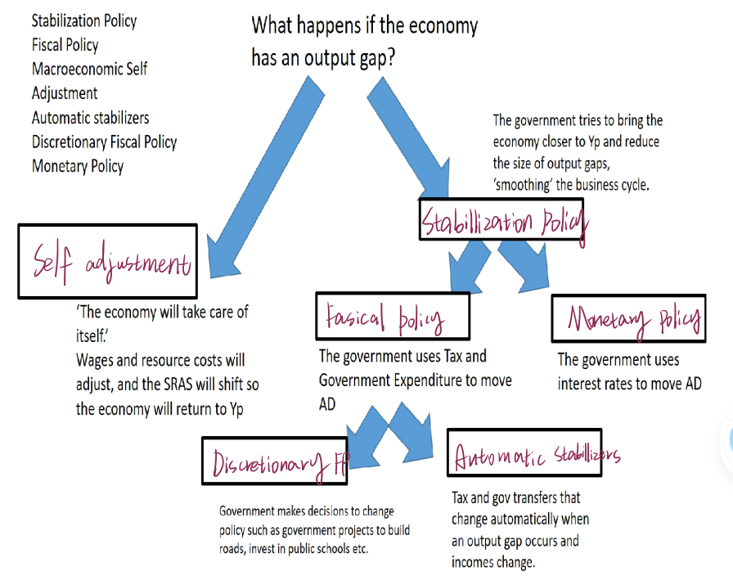
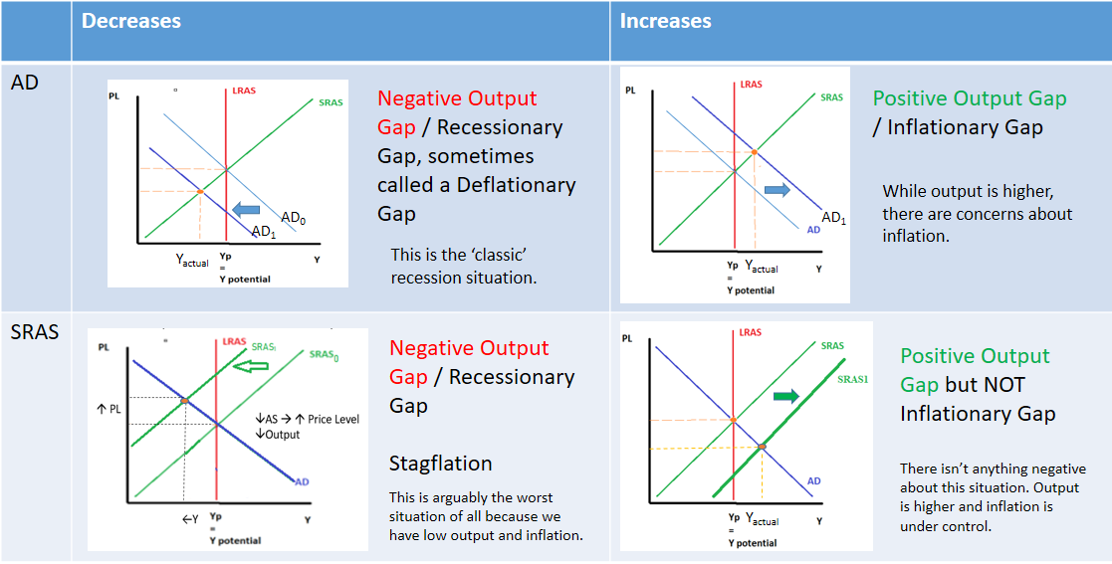
Note: Self Adjustment ≠Automatic Stabilizers
(Self Adjustment = SRAS shift, no government involved at all
Automatic Stabilizers = Fiscal Policy = government involved)
Stabilization Policy
Fiscal Policy

Unit 4
Money
Definition: can be universally accepted as a medium of exchange.
- Medium of Exchange – used to buy goods and services
- Store of Value – we can hold money and spend it in the future.
- Unit of Account – we can measure the value of things using money.

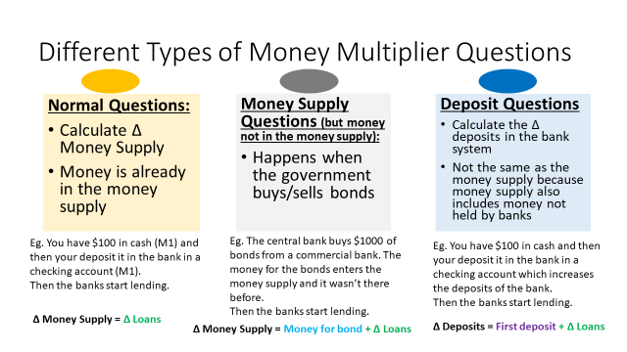
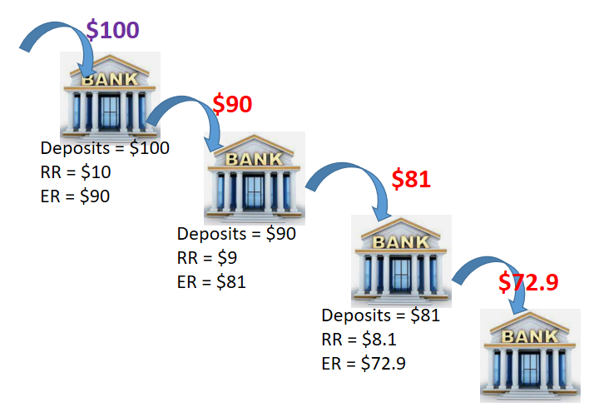
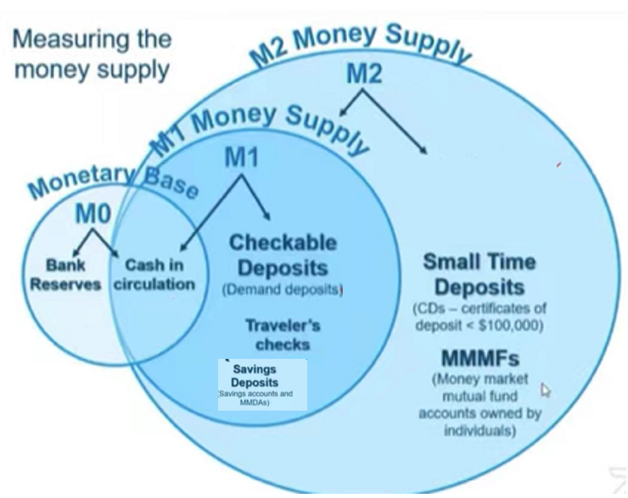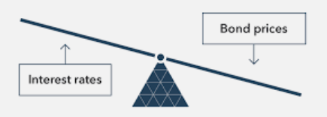
Money Multiplier
=
1/RRR
∆Money Supply = ∆Loans = First Loan x 1/RRR
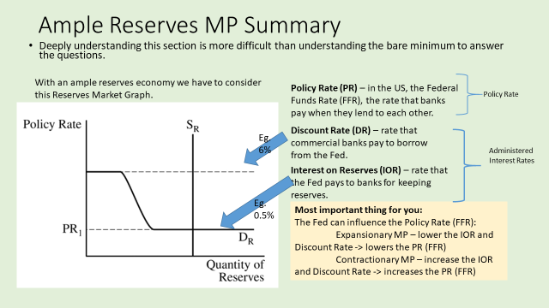
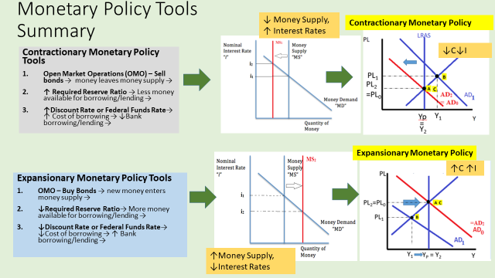

Unit 5
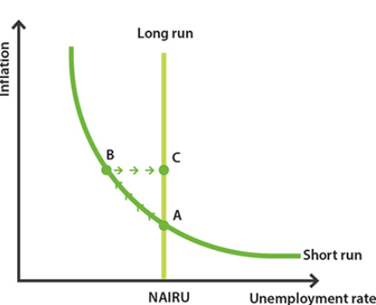
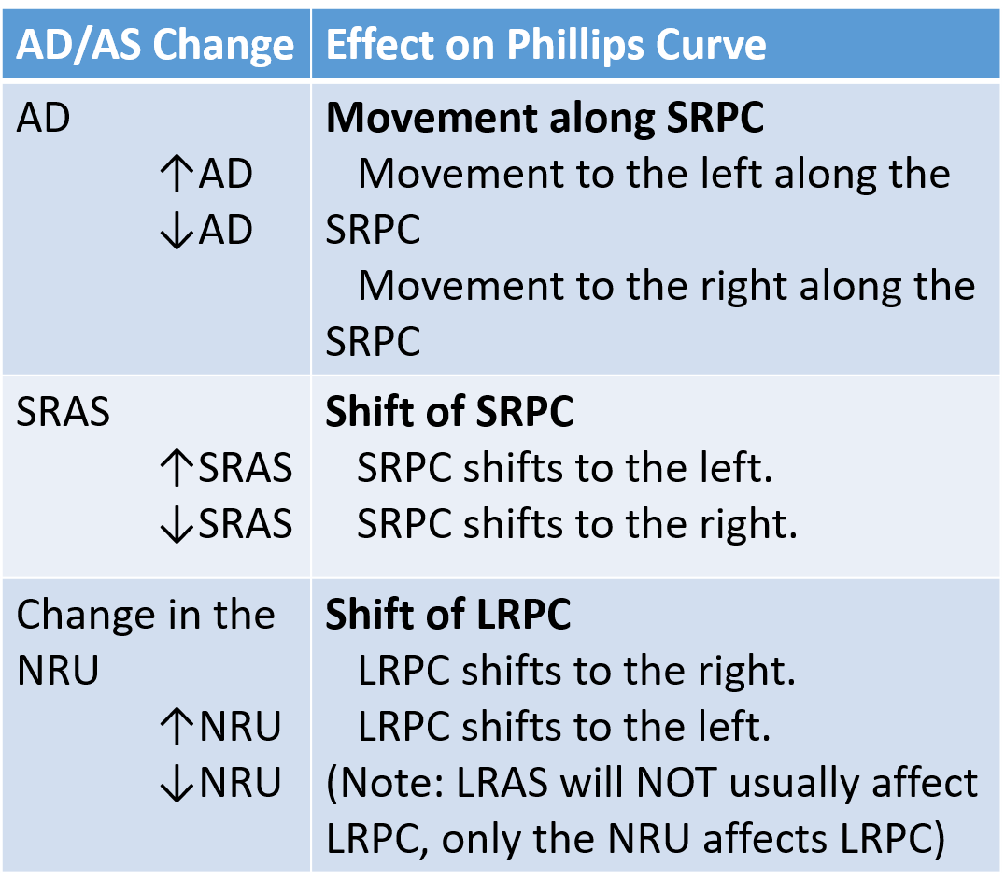

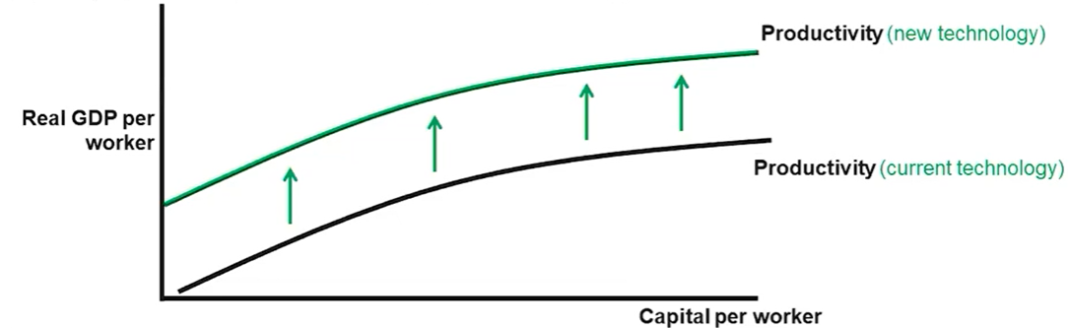
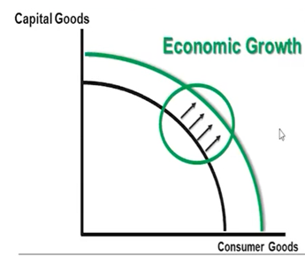
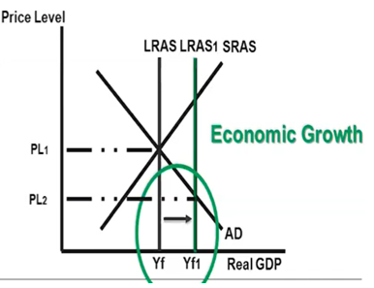
Public Policies – Supply Side Policy
- Less tax and social security
  - We assume that the private sector is more efficient in general, and that lower tax will incentivize people to work harder and invest more, resulting in higher output
    - Higher Investment
    - Improved human capital
- Less regulation and more privatization
  - Businesses can operate freely which lowers their costs, increasing their supply.
- Policies that increase the technology or resources
  - Increasing spending on education
  - Increasing spending on research and development
  - Increasing spending on infrastructure and physical capital
  - Increasing spending on training to improve labor productivity
  - Reducing household income taxes and business income taxes
Economic Growth Graphs
Economic Growth
Economic Growth → ↑RGDP per capita→ ↑Productivity
Productivity increases determined by:
- Amount of capital stock
- Technology
- Human Capital

Quantity Theory of Money
MV = PY
Assume V and Y are stable

M = money supply
V = Velocity of money (how many times money is used in transactions in a year)
P = Price Level
Y = RGDP
PY = NGDP

‘Crowding Out’ = Government has expansionary FP -> ↑Budget Deficit -> ↑Government borrowing -> ↑Demand Loanable Funds -> ↑Interest Rate-> ↓Private Investment-> ↓Capital Formation
Note: Many questions involve this concept
If there is an increase of IR caused by an increase demand of capital goods then private investment will still increase.

Unit 6
Balance of Payments = CA + CFA = 0

Capital Account / Financial Account (CFA)
- Net Financial Investments
  - Stocks, Bonds, Other financial assets
- Net Real Investments
  - Foreign Direct Investment (eg. factories, retail stores)
  - Property and Equipment
Current Account (CA)
- Net Imports and Exports
- Net Factor Incomes (from ownership of land, capital and enterprise)
- Net Transfers
  - Remittances
  - Foreign Aid

Surplus = more money coming in to country
Deficit = more money leaving country

↑Demand of Currency A = ↑Supply of Currency B (and vice versa)
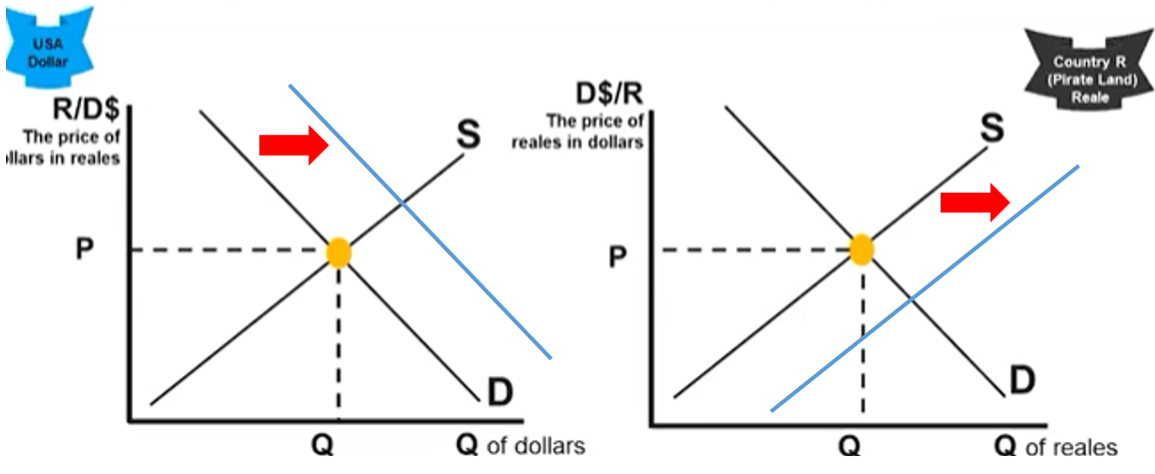

→↑Supply Loanable Funds →↑Private borrowing and investment →↑Capital Formation
Expansionary fiscal policy→↑Real Interest Rate (crowding out)

→↑Capital Inflows→↑Exchange Rate

→↓Net exports (↑imports↓exports)→↓AD
Contractionary Monetary Policy
→↓MS→↑Interest Rate (Money Mkt)

Note: However, in many cases, these are secondary effects.

Eg. If there is an increase of exports in a country, even though this increases the Exchange Rate which might decrease exports slightly, the overall effect is still an increase of exports

